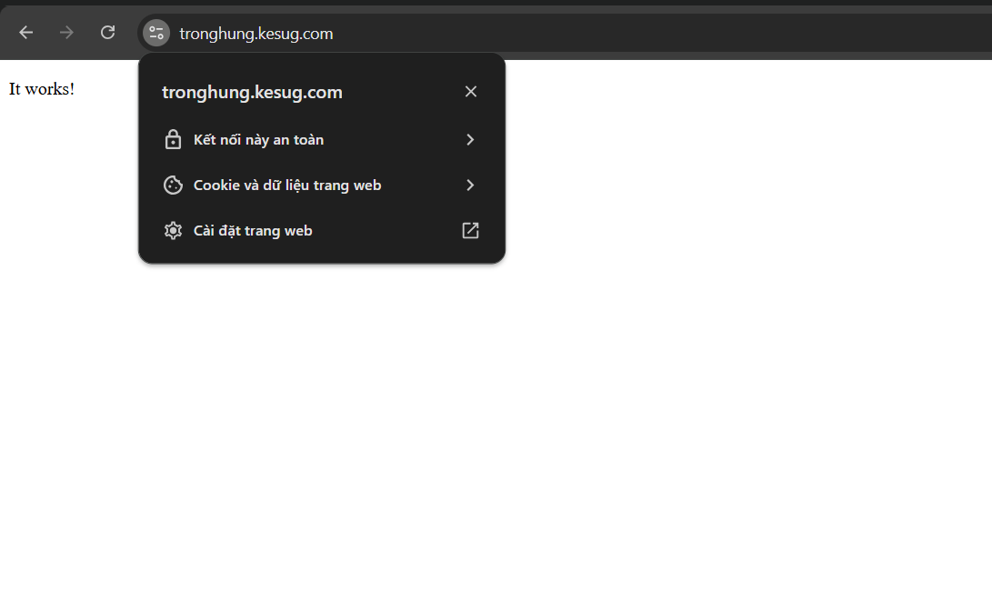
openssl s_client -connect tronghung.kesug.com:443 -servername tronghung.kesug.com -tls1_3 -showcerts
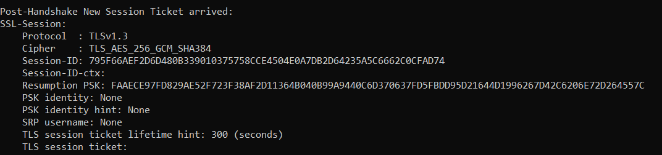
openssl s_client -connect tronghung.kesug.com:443 -servername tronghung.kesug.com -tls1_2 -showcerts
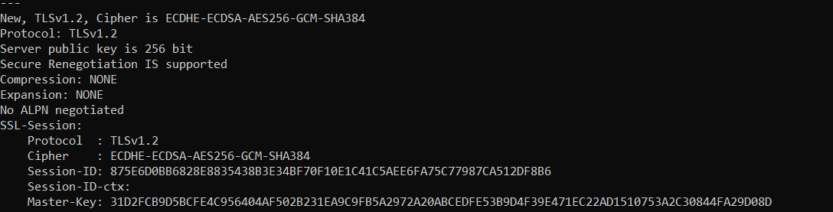
openssl s_client -connect tronghung.kesug.com:443 -servername tronghung.kesug.com -showcertsopenssl s_client -connect tronghung.kesug.com:443 -servername tronghung.kesug.com -showcerts
